Milestone 2 - ERD Design & Normalization
Normalized database schema for the game, tournament, player, group, and chat system

Final Normalized Schema
Table | Columns
PLAYER | PID PK; first_name; last_name; email UNIQUE; rank_elo
GAME_TYPE | GT_ID PK; name; time_limit_sec; board_size
TOURNAMENT_STRUCTURE | struct_ID PK; format; rounds; seeding; details
TOURNAMENT | TID PK; reward; tournament_time; GT_ID FK; struct_ID FK
TOURNAMENT_PARTICIPANT | TID PK/FK; PID PK/FK; seed_number; placement
ARENA | arena_ID PK; arena_name UNIQUE
GAME | GAME_ID PK; GT_ID FK; TID FK NULL; arena_ID FK; start_time; end_time
GAME_PLAYER | GAME_ID PK/FK; PID PK/FK; player_slot; result; points
GAME_MOVE | GAME_ID PK/FK; move_number PK; PID FK; move_text; move_time
FRIENDSHIP | PID1 PK/FK; PID2 PK/FK; status; created_at
PLAYER_GROUP | GID PK; group_name; owner_PID FK; created_at
GROUP_MEMBER | GID PK/FK; PID PK/FK; role; joined_at
CHAT | CID PK; chat_type; GID FK NULL; created_by_PID FK; created_at
CHAT_MEMBER | CID PK/FK; PID PK/FK
MESSAGE | message_ID PK; CID FK; sender_PID FK; body_text; sent_at
MESSAGE_MEDIA | media_ID PK; message_ID FK; media_url; media_type
MESSAGE_READ_RECEIPT | message_ID PK/FK; PID PK/FK; read_at

Updated Normalized ERD Image
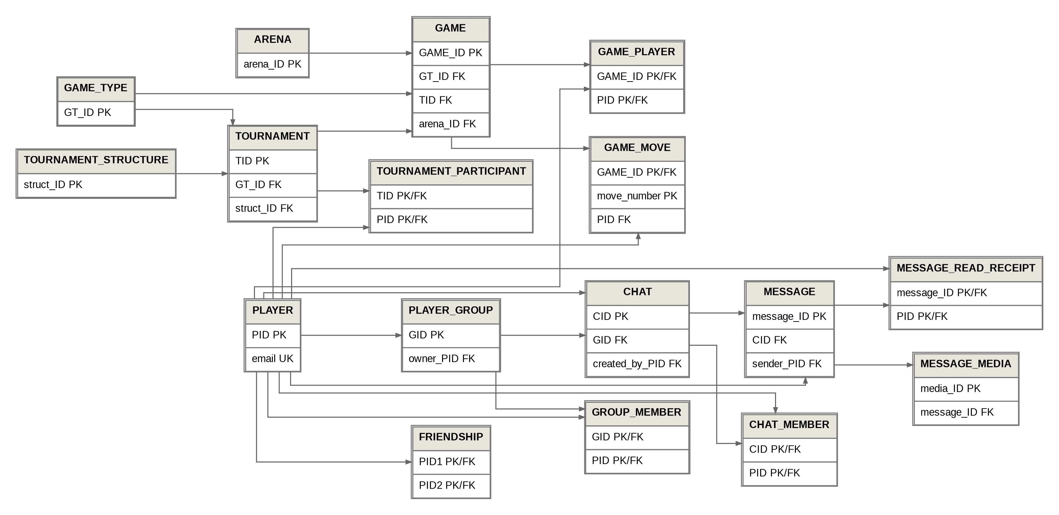
Figure 1. Normalized ERD schema image based on the Mermaid ERD structure.

Step 1 - Apply Normalization

First Normal Form (1NF)
1NF requires each column to hold one atomic value, no repeating groups, and a clear primary key for each row.
Table | Issue / Change | Why
PLAYER | No major issue. Renamed Gmail to email and made it unique. | Each player has one ID, name, email, and rating.
GAME_TYPE | No issue. Renamed GAMETYPE to GAME_TYPE. | Values such as name, time limit, and board size are atomic.
TOURNAMENT_STRUCTURE | No major issue. Renamed STRUCTURE. | Each row stores one format, round count, seeding method, and details field.
TOURNAMENT | Renamed time to tournament_time and added GT_ID. | Keeps values clear and connects each tournament to a game type.
TOURNAMENT_PARTICIPANT | Added composite PK (TID, PID). | Each player appears once per tournament.
GAME | Removed moves, P1_ID, P2_ID, Winner, and points. | Moves and players are repeating data and belong in separate tables.
GAME_PLAYER | Created from player-specific game data. | Stores one row per player per game.
GAME_MOVE | Created from GAME.moves. | Stores each move as its own row.
FRIENDSHIP | Added composite PK (PID1, PID2). | Each friendship pair is uniquely identified.
PLAYER_GROUP | Renamed GROUP to avoid SQL reserved word. | Group data remains atomic.
GROUP_MEMBER | Renamed GROUP_LIST and added PK (GID, PID). | Each group membership is one row.
CHAT | Removed PID1 and PID2. | Participants are repeating values and now belong in CHAT_MEMBER.
CHAT_MEMBER | Created to store chat participants. | Supports direct chats and group chats.
MESSAGE | Renamed OUR_CHATS and removed media/is_read. | Message text and send time remain atomic.
MESSAGE_MEDIA | Created for message attachments. | A message can have multiple media files.
MESSAGE_READ_RECEIPT | Created for read status. | Read status depends on a message and a reader.

Second Normal Form (2NF)
2NF requires every non-key attribute to depend on the whole primary key, especially in tables with composite keys.
Table / Group | 2NF Justification
Single-key tables | PLAYER, GAME_TYPE, TOURNAMENT_STRUCTURE, TOURNAMENT, ARENA, GAME, CHAT, MESSAGE, and MESSAGE_MEDIA have single-column primary keys, so their non-key attributes depend on that full key.
TOURNAMENT_PARTICIPANT | seed_number and placement depend on the full combination of TID and PID, not only one part of the key.
GAME_PLAYER | player_slot, result, and points depend on both GAME_ID and PID.
GAME_MOVE | move_text, move_time, and PID depend on the GAME_ID plus move_number combination.
FRIENDSHIP | status and created_at depend on the full player pair PID1 and PID2.
GROUP_MEMBER | role and joined_at depend on both the group and the player.
CHAT_MEMBER | No extra non-key attributes are stored, so there is no partial dependency.
MESSAGE_READ_RECEIPT | read_at depends on both the message and the player who read it.

Third Normal Form (3NF)
3NF requires that non-key attributes do not depend on other non-key attributes. Redundant and transitive dependencies were removed.
Table | 3NF Justification
PLAYER | No transitive dependency. Name, email, and rank_elo describe the player directly.
GAME_TYPE | No transitive dependency. Time limit and board size describe the game type directly.
TOURNAMENT_STRUCTURE | No transitive dependency. Format, rounds, seeding, and details describe the structure directly.
TOURNAMENT | GT_ID and struct_ID are foreign keys. Tournament facts depend directly on TID.
TOURNAMENT_PARTICIPANT | Seed and placement describe the player participation in a specific tournament.
GAME | Winner and player-specific points were removed because they are not game-level facts.
GAME_PLAYER | Result and points describe a player in a specific game.
GAME_MOVE | Move data depends on the game and move number, not on another non-key column.
FRIENDSHIP | Friendship status depends only on the player pair.
PLAYER_GROUP | owner_PID identifies the owner. Ownership is not duplicated elsewhere.
GROUP_MEMBER | Role depends only on the membership pair.
CHAT | Chat participants were moved to CHAT_MEMBER to remove dependency issues.
CHAT_MEMBER | Membership depends on the chat and player combination.
MESSAGE | is_read was removed because it depends on the reader as well as the message.
MESSAGE_MEDIA | Media details depend only on the media row.
MESSAGE_READ_RECEIPT | read_at depends on the message-reader pair.

Step 2 - Remove Duplicates
The following duplicate, repeated, or overlapping data was removed or restructured:
- Removed GAME.P1_ID, GAME.P2_ID, and GAME_HISTORY. The GAME_PLAYER table now stores the player-game relationship.
- Removed GAME.Winner. The winner can be identified from GAME_PLAYER.result.
- Moved GAME.points to GAME_PLAYER.points because points belong to a player in a game.
- Removed GAME.moves and created GAME_MOVE so each move is its own row.
- Removed CHAT.PID1 and CHAT.PID2 and created CHAT_MEMBER to support any number of chat participants.
- Removed OUR_CHATS.is_read and created MESSAGE_READ_RECEIPT because read status is different for each reader.
- Removed OUR_CHATS.media as a single field and created MESSAGE_MEDIA to support multiple attachments.
- Renamed unclear or risky names: GROUP to PLAYER_GROUP, GROUP_LIST to GROUP_MEMBER, OUR_CHATS to MESSAGE, Gmail to email, time to tournament_time, and ID in GAME to GAME_ID.

Step 3 - Updated ERD Relationships
PLAYER 1 --< GAME_PLAYER >-- 1 GAME
PLAYER 1 --< GAME_MOVE >-- 1 GAME
GAME_TYPE 1 --< GAME
GAME_TYPE 1 --< TOURNAMENT
TOURNAMENT_STRUCTURE 1 --< TOURNAMENT
TOURNAMENT 1 --< TOURNAMENT_PARTICIPANT >-- 1 PLAYER
TOURNAMENT 1 --< GAME
ARENA 1 --< GAME
PLAYER 1 --< FRIENDSHIP >-- 1 PLAYER
PLAYER 1 --< PLAYER_GROUP
PLAYER_GROUP 1 --< GROUP_MEMBER >-- 1 PLAYER
PLAYER_GROUP 1 --< CHAT
CHAT 1 --< CHAT_MEMBER >-- 1 PLAYER
CHAT 1 --< MESSAGE
PLAYER 1 --< MESSAGE
MESSAGE 1 --< MESSAGE_MEDIA
MESSAGE 1 --< MESSAGE_READ_RECEIPT >-- 1 PLAYER

Conclusion
The final design satisfies 1NF, 2NF, and 3NF. Repeating groups were separated into related tables, composite-key tables only store attributes that depend on the full key, and redundant or transitive dependencies were removed.

